Palm Beach County Criminal Justice Commission
Community Engagement Team
and Partner Agencies

Presents


Please Join us for a
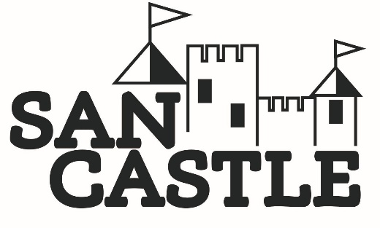
COMMUNITY CONVERSATION

“REFLECTING OUR YOUTH’S REALITY”

Tuesday, April 30, 2019 5:30 p.m. to 8:00 p.m.
Rolling Green Elementary School Cafeteria
550 Miner Road, Boynton Beach

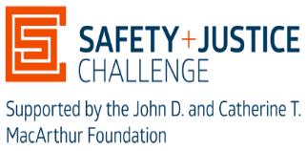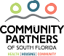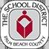

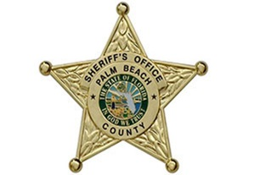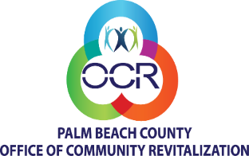

Dinner provided courtesy of the MacArthur Foundation

